**BUGS FOR CASTE-CUM-INCOME CERTIFICATE**

Hidden field is shown in return to edit application by deo.

Caste Name Hidden

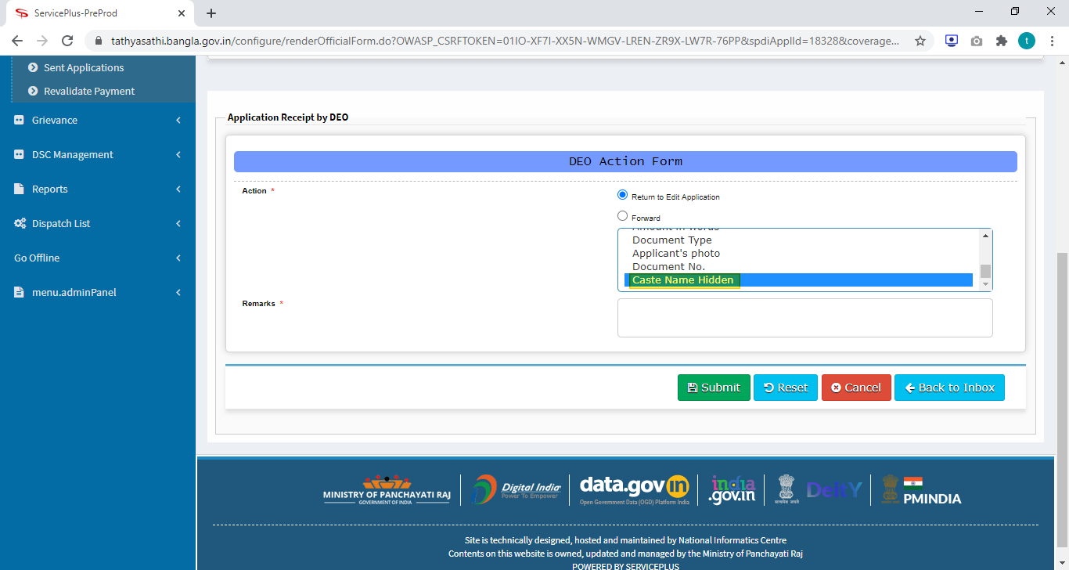

Office Seal of Gram Panchayat should be in right side of Qr code

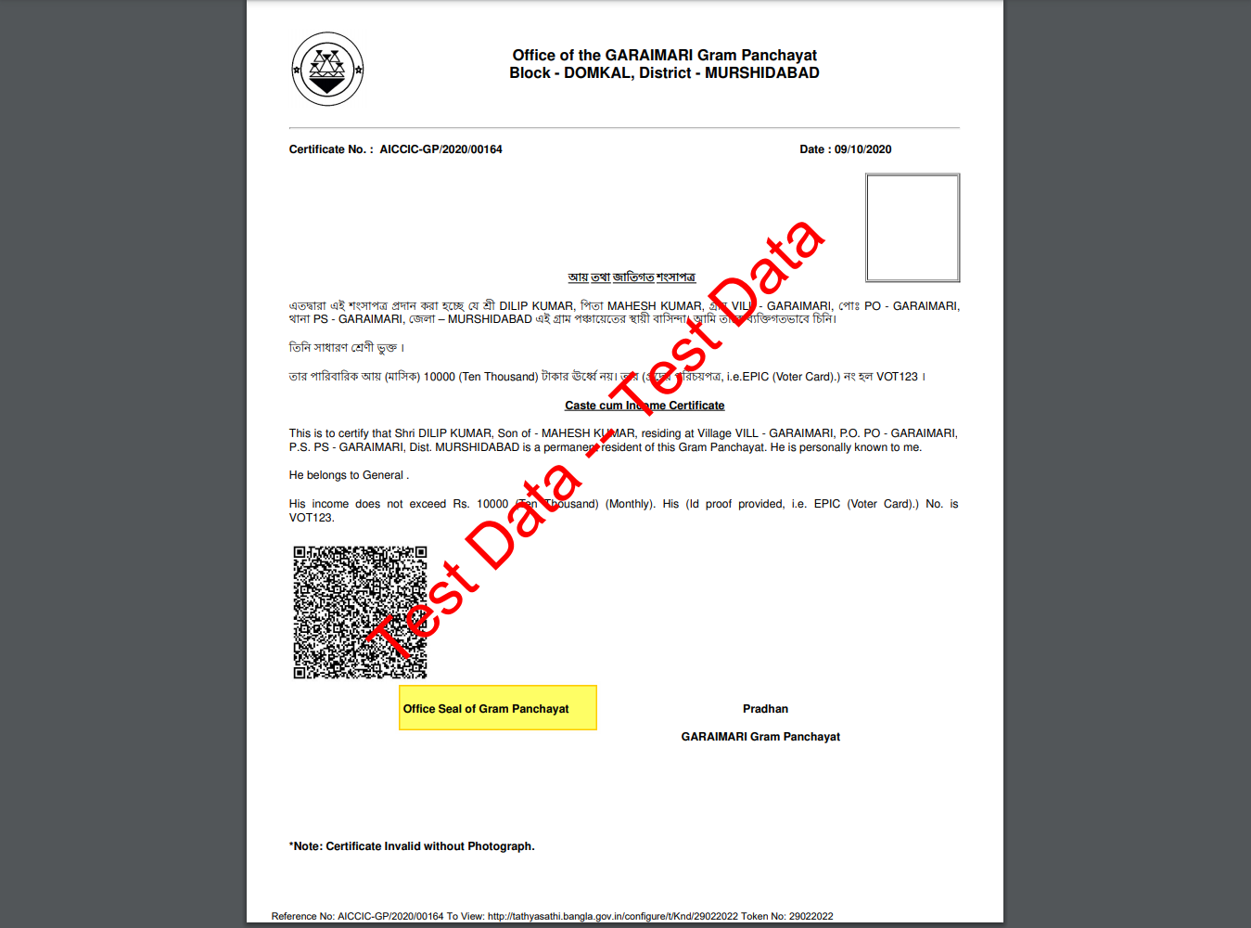

**No more issues found.**